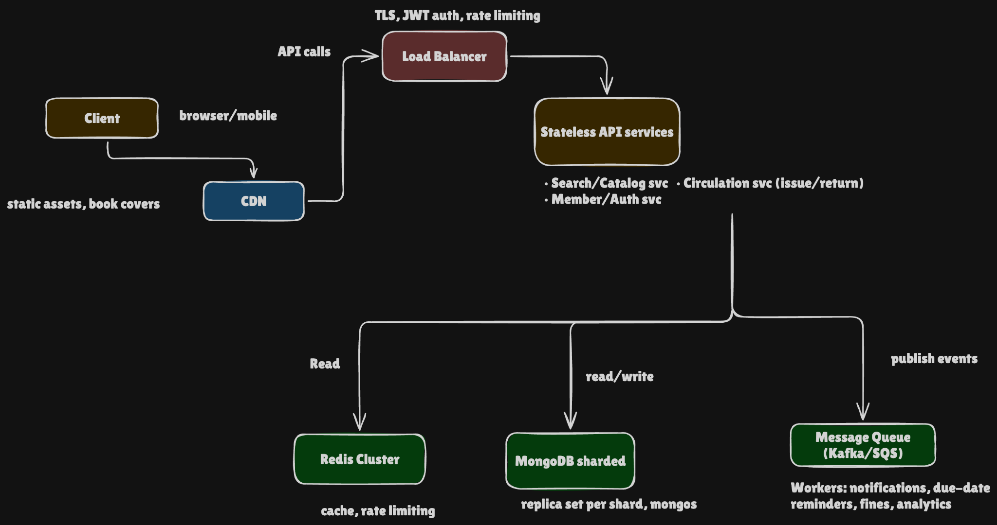

a) Architecture
Here's how I'd lay out the system, starting from the edge and working inward.
Book covers and other static files go on a CDN backed by object storage, so most of that traffic never reaches our API at all. Requests that do come through hit a load balancer and API gateway, which handle authentication and rate limiting and spread requests across the API instances.
The API services are stateless, so we can add more instances whenever we need to. I'd split search/catalog from circulation (issue/return), so that a burst of people searching can't slow down someone returning a book.
Redis sits in front of MongoDB and holds popular book info and search results, which saves a lot of repeated database reads. MongoDB itself runs as a sharded cluster, with each shard being a replica set for high availability. The secondaries can take on read-heavy search traffic.
Anything that doesn't need to happen while the user waits (notifications, fines, reminders, analytics) goes onto a message queue and gets handled by background workers.

b) Single cluster or sharded?
I'd go with sharding. With around 2 million members and 500 libraries, BorrowRecord will keep growing. Every semester's first week also brings a flood of issue and return writes. A single primary would be taking all of that alone, whereas sharding spreads both the storage and the write load.
Book collection (each document is one library's copy info for a title). Shard key: { libraryId: 1, isbn: 1 }
- Most book queries are for one specific library, so MongoDB can send them straight to the right shard instead of asking every shard.
- Adding ISBN gives the key enough variety to spread documents out within a library.
- It isn't a steadily increasing value like a timestamp or ObjectId, so new inserts won't all pile onto one shard.
BorrowRecord collection. Shard key: { libraryId: 1, memberId: 1 }
- Common lookups, like "what has this member borrowed?" or a fine check, can be routed to a single shard.
- Library-wide reports, like overdue lists, can use the libraryId prefix and skip shards that don't hold that library's data.
- I'd deliberately avoid issuedAt, since an always-increasing timestamp creates a hot shard. I'd also avoid bookId, because looking up a member's history would then mean querying every shard.
There is one trade-off: a Book document and its BorrowRecord can end up on different shards. That means the issue flow can't rely on a cross-shard transaction, and I've designed it so it doesn't.

c) The most read-heavy operation: book search and availability lookup
Search and availability checks will take the most reads. Students tend to search several times before they actually borrow anything, and this is also the part that will absorb the 10× jump in traffic.
I'd use Redis with a cache-aside pattern, and I'd cache three things separately because they go stale at different speeds.
Book metadata (title, author, ISBN, cover URL) rarely changes.
- Key: book:{libraryId}:{isbn}
- TTL: roughly 1 to 24 hours. If a book is edited or deleted, I'd remove its cache entry right away.
Search result pages don't need to be perfectly fresh.
- Key: search:{libraryId}:{hash(query,filters,page)}
- TTL: about 60 seconds. I'd add some random jitter to the TTLs and use single-flight locking, so a popular entry expiring doesn't send a stampede of identical queries to MongoDB.
Availability changes often, so it gets its own entry.
- Key: avail:{libraryId}:{isbn}
- TTL: about 5 to 10 seconds, and I'd update or delete the entry whenever a book is issued or returned.
Redis is only there to make reads faster and the UI snappier. MongoDB stays the source of truth when a book is actually issued, so a slightly stale cached number can never cause an extra copy to be handed out.

d) Keeping availableCopies from going negative
I'd make the check and the decrement a single atomic operation on the Book document:
const result = await books.findOneAndUpdate(
{ libraryId, isbn, availableCopies: { $gt: 0 } },
{ $inc: { availableCopies: -1 } }
);
If nothing comes back, no copy is available and we reject the request. MongoDB does the condition check and the decrement together, so two people can't both grab the last copy. As a second safety net, I'd add a schema validation rule requiring availableCopies >= 0, and an idempotency key so a client retry doesn't create a duplicate issue.
Once the decrement succeeds, we insert the BorrowRecord. A unique constraint on active member-book loans stops duplicate active records. If creating the record fails, we compensate by incrementing the count back.
Why not the alternatives?
- Optimistic locking works, but for in-demand books during the semester rush there would be constant version conflicts, with retries piling extra load on the database.
- Distributed locks (e.g. in Redis) add another network dependency and bring in lock-expiry problems and new failure modes. MongoDB can already do the atomic operation we need.
- Queue serialization is correct, but it adds latency and complexity to something one atomic update handles safely.
- Multi-document transactions are heavier and get awkward when the documents sit on different shards. Decrement-plus-compensation avoids that.

e) Handling the 10× semester spike without overspending
The nice thing here is that the spike is predictable. Academic calendars are known well in advance, so we can use scheduled scaling together with regular autoscaling instead of paying for peak capacity all year.
- API layer: Run the stateless services on Kubernetes or ECS with a small baseline. Scale up a day or two before the semester starts, then let CPU- or request-based autoscaling take over during the peak.
- Database: Use a managed MongoDB service with autoscaling, or raise capacity just before semester week and bring it back down afterward. Send suitable search reads to the secondaries.
- Cache: Redis should absorb most repeated searches. We can pre-warm popular queries before day one so less reaches MongoDB.
- Queue: Keep notifications, analytics, fines, and reminders asynchronous so issuing and returning stay fast. Workers can run on cheaper capacity where possible.
- Protection: Rate-limit per user and per library, and be ready to shed non-essential work, such as recommendations, if the system gets overloaded.
- Testing and staggering: Load-test at the expected 10× level before every semester. Where campuses are willing, staggering orientation or book-issue sessions also spreads out demand.

